Overseas Investment Analysis
  - Case Analysis of Nestle Perrier for Spain

Table of Contents
Introduction 3
Internal Analysis 4
Value Chain Analysis 4
External Analysis 8
Five forces 8
Pestle Analysis 12
Risk register 16
Probability Impact Analysis & Priority of Risk 18
Strategy for risk 20
SWOT analysis 21
Strengths 21
Weakness 22
Opportunities 23
Threats 23
Conclusion for the decision 24
References 25

Introduction

Being one of the leading companies operating within the food and drinks segmentanNestle has marked a global presence. The company has an expanded product portfolio with products ranging from powdered beverages, liquid effect, bottled water, milk related products and ice cream, nourishment and health care, ready dishes and cooking supports, confectionery items and pet care through more than 2000 brands (Nestle Ltd., 2014a). With its headquarters in Vevey, Switzerland the company has been serving the world for more than 140 years now (Nestle Ltd., 2014b). The company aspires to be a leader within the segment through its strategic approach to sustainability. Nestle has a strong and aggressive growth strategy that has resulted in its depict growth beyond leaps and bounds. Irrespective of being subjected to challenges related to supply chain, human resources, technological changes, consumer dynamism, organisational management, brand management and sustainability the company has been fearlessly progressing.
The primary focus of this study is to assist Nestle in taking decisions for its Perrier Brand. The brand which essentially indulges in the provision of bottled sparkling natural mineral water has the year to issues which have left Nestle at the crossroads. The company has to either take decisions for its divestment or to relocate it. In this study, the option of relocation has been scrutinised with the destination being Spain. In order to do so an internal and external environmental analysis has been undertaken. Internal analysis using the Value Chain Model outlines the factors formulating the value chain for Nestle’s Perrier brand whereas the external environment provides for analysis of competitive pressures using Porter’s 5 Forces Model and other macro environmental factors using PESTLE Model. Further risks related to the decision of setting up in Spain are being registered and then Probability Impact Analysis is pursued. The risks are then prioritised and strategies for dealing with them are also suggested. Finally, a conclusion is drafted stating the feasibility of decision for relocating Perrier brand to Spain if taken.

Internal Analysis

Value Chain Analysis
Value chain analysis comprises of examination of differing activities of an organisation that link differing operational phases right from sourcing of raw materials to meeting target customer needs and provision of post-sale services to them (Crain & Abraham, 2008). The main intention of this analysis is to determine the extent of value generated by each activity and their contribution towards overall organisational profitability. An organisation aims at deriving maximum value and generating minimal wastages. The value chain activities are segmented under two major heads that are primary and secondary as depicted in the diagram below:

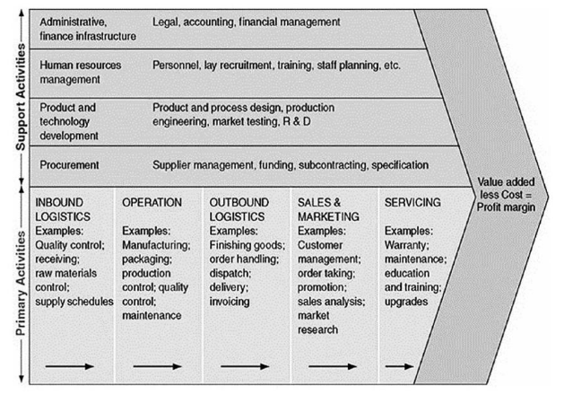
Figure 1 Value Chain Model
Source: (Christiansen, 2015)
Nestle has been working hard to design its supply chain to make it sustainable across the globe including Spain. Sustainability has been the main driving force for Nestle to achieve long-run growth and enhance its overall environmental performance across the corporation (Vorhies, 2012).
Primary Activities
Inbound Logistics: Nestle Perrier has strong relationships and network with 3rd party logistics which makes its logistics highly efficient and effective along with being environmentally friendly. The products are transported using the most environmentally friendly and cost-effective mechanisms (Thomas Publishing Company, 2013). Like Perrier brand is transported through boats thus maximising operational efficiency and covering maximum locations possible ( Nestle Waters, 2016).
Operations: For Perrier, Nestle uses a very unique and integrated manufacturing process. The process is intricate as it is a process developed by amalgamating traditional methods with modernised technologies (Nestle Waters, 2015). The most significant aspect of this process is carbonation which is also responsible for the product’s success.
Outbound Logistics: The outbound logistics of Nestle for all its brands is highly integrated (Bhattacharya, 2010). It is a combination of both push and pulls strategies that establish a link between the company and its target customers as seen in the figure below:
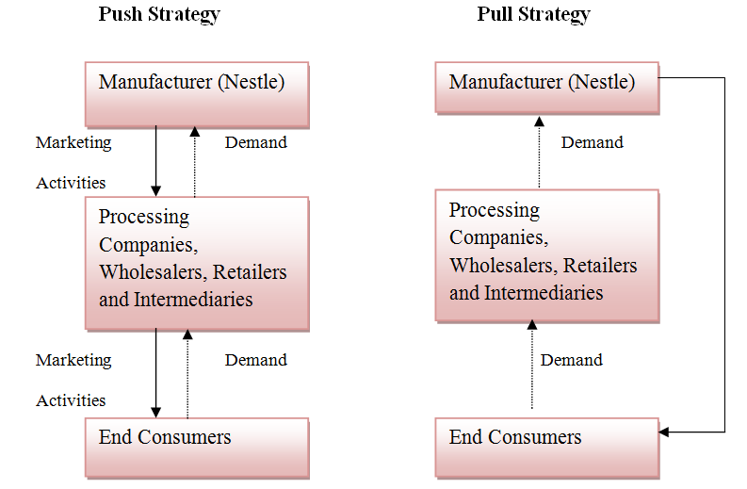
Figure 2 Nestle's Pull and Push Strategies
Source: (Udas, 2014)
The overall outbound distribution network starts with the main storehouse of the company and progresses towards carriage and forwarding agent. From there it is split into two divisions one comprising of super stockiest and the other having distributors. Distributors deal with wholesalers and retailers whereas super stockiest moves the products to re-distributors who send the products to retailers. The retailers finally sell the products to customers (Udas, 2014).
Sales and marketing: From the figure above it can be determined that sales and marketing by Nestle are undertaken through both push and pull strategies. Marketing activities are undertaken to lure customers as well as middlemen in form of sales promotions to ensure that the products are duly sold (Udas, 2014).
Servicing: For the provision of quality services to the consumers Nestle Perrier has a toll free number which the customers can call up to provide their feedback (both positive and negative) (Nestle Waters, 2015). Immediate actions are being taken in circumstances of negative feedback to report issues and ensure customer satisfaction.
Secondary Activities
Administrative: Legal compliance with norms specified by Food and Drug Administration (FDA) in general and specific norms related to water under the Safe Drinking Water Act (FDA) (Nestle Waters, 2015). It also abides by norms stipulated under U.S. Environmental Protection Agency (EPA) (Nestle Waters, 2015). The manufacturing unit is regularly monitored and audited by Bureau Veritas for compliance of norms by International Bottled Water Association (IBWA) with regards to quality and other specifications (Nestle Waters, 2015).
Human Resource Management: Human resources (HR) an integral aspect of Nestle. The company ensures quality employees are employed. Further, these employees qualities are nourished and enriched through regular training and development programs. Employees are provided with a safe working environment which is also verified and certified annually by Hazard Analysis Critical Control Point (HACCP) (Nestle Waters, 2015).
Product and Technology Development: For optimal efficiency, Nestle uses ultra-modern technologies like telematics (Thomas Publishing Company, 2013). Further, it is progressing towards usage of natural refrigerant for its products as well as usage of electric cars. The company has a higher inclination towards modern technology utilisation.
Procurement: The primary raw material that is water is sourced depending upon its natural composition reliability, contamination levels, taste and obtainability. The suppliers are bound to abide by the supplier code and sustainability code as adopted by Nestle.

External Analysis

Five forces
Competing forces within an industry play a dominant role in determining the influence of external market parameters on a business. Through an analysis of these forces, an organisation will be in a position to determine the overall market attractiveness and thus take strategic decisions of being within the industry (Porter, 2008). The 5 forces of this model are depicted in the figure below:
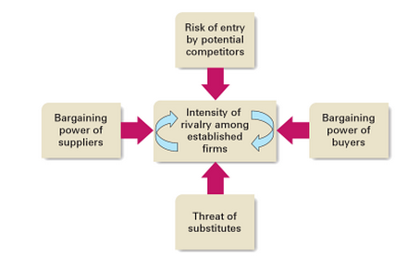
Figure 3 Five Force Model by Porter
Source: (Hill & Jones, 2009)
The model plays a significant role in determining the varied threats and prospects present within the industry to which an organisation will be subjected to. In this section, the competitive forces that might be experienced by Nestle for its Perrier brand in Spain have been identified in details.
Potential Competitors (Entry Risks): Due to water shortages experienced by Spain it is very likely for companies to enter the water industry of the nation. Water shortages are a result of extreme climatic conditions as experienced by the country (Deloitte, 2014). Furthermore, than drinking water, water in Spain is used for utility purposes. Companies selling like fruit juices, energy drinks and other aerated drinks in Spain have their set up ready and thus can always expand into drinking water product category. Further, as the government allows 100% FDI it is lucrative for potential competitors to enter the industry (Data Monitor, 2010). But for new players, setting up mineral water set up requires huge capital investments which might be a discouraging factor.
Suppliers (Bargaining Power): Suppliers of water in Spain mainly involve in the supply of saline water which needs to be desalinated for drinking purposes. These suppliers to a larger extent are regulated by government bodies due to their higher involvement. Due to water scarcity, the bargaining power of suppliers is high which is moderated owing to easy access to water basins by companies.
Customers (Bargaining Power): In Spain the consumer bargaining power for very high. It is owing to the fact that there are a large number of options offered by direct competitors empowering the consumer to choose from such a wide variety of assortment. Similarly, easy availability of an array of substitute products enhances customer’s bargaining power. Though consumers have higher purchasing power in Spain due to higher unemployment rates experienced by the nation they might opt for cheaper options like freely available tap water which is drinkable (Smith et al., 2014).
Prevailing Competition (Threats): One of the major players within the water industry in Spain is Aguas Font Vella y Lanjaron which also has a market share of 17% (Statista, 2016). However, there are a large number of player present within the industry in Spain offering water to customers as seen in the figure below:
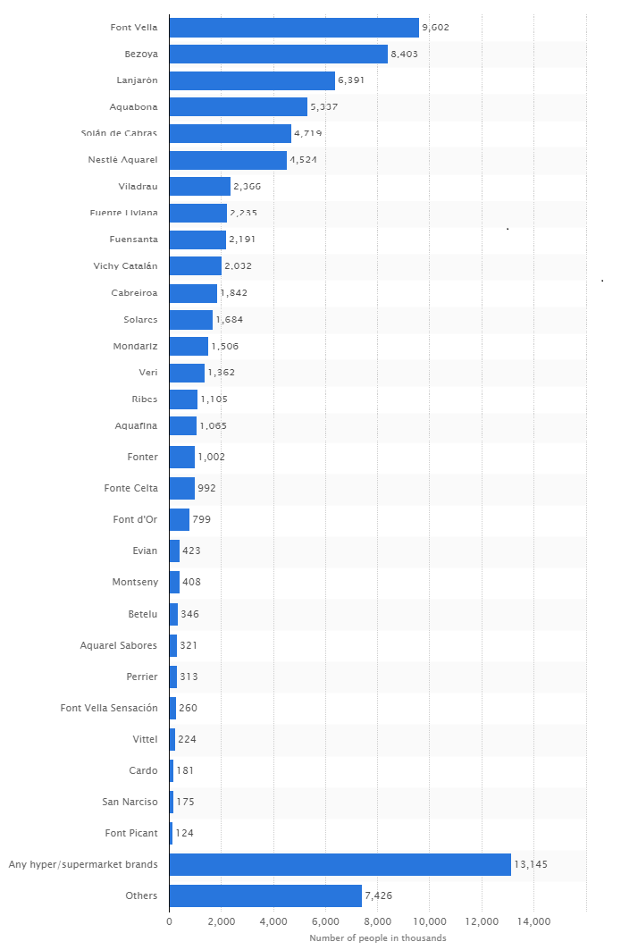
Figure 4 Existing Players (Drinking Water) in Spain
Source: (Statista, 2016)
Given the fact that the population of Spain is approximately 64.77 million people the competition intensity is very dense within the industry (Worldometers.info, 2017). The company are not only exposed to competition from domestic or regional players but also from international ones thus making the market saturated.
Substitute (Threats): Spain is a developed nation with an effective government. There is no substitute for drinking water. But then people do opt for tap water which is drinkable in Spain (Xie, 2016). Further options like fruit juices, energy drinks and other aerated drinks substitute water consumption (Popkin et al., 2006). As these companies are providing for healthy options by reducing sugar content and carbonation in their products, consumers are more likely to choose them. Further juices have higher nutritional value along with along with good taste thus raising the threat levels for drinking water.

Pestle Analysis
A Pestle is a strategic tool that is used by organisations as a technique to gauge the market by analysing differing macro factors present within the environmental and has bearing on organisational operations. The varied elements of Pestle Analysis are political, economic, environmental, technological, environmental and legal (Marmol, 2015).
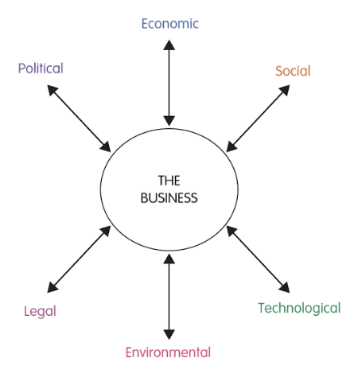
Figure 5 PESTLE Analysis
Source: (Gillespie, 2012)
It helps in identifying varied issues and opportunities present within the business environment and thus assisting in the assessment of potential future of a product and service or organisation (Yüksel, 2012). With the help of Pestle analysis in this section, an examination of the varied external environmental factors presents within Spain. This analysis is done to identify the implication of these factors on Perrier brand of Nestle in case the company plans to divest in this country.
Political Factors: The government of Spain plays a significant role in supporting the overall development of the region. Being a democratic nation, the government has taken strong measures towards fiscal consolidation of the nation. It further shares positive and strong relationships with European Union (EU) nations. Politically the nation is stable and is also an active member of international organisations namely United Nations, North Atlantic Treaty Organisation (NATO), Organisation for Economic Co-operation and Development (OECD), and World Trade Organisation (WTO) (Market Research Reports Inc., 2017). The overall government has been reorganised and restructured to manage water-related regulations and support its smooth economic development (Deloitte, 2014).
Economic Factors: The country is considered to be a favourable destination for foreign direct investments (FDI) owing to its supportive policies. Spain in the year 2012 experienced a FDI of 27.8 billion USD (Lucintel, 2013). Consumption of bottled water is Spain is very high and in 2016 the sales of bottled water increased by 6% in terms of volume (Euromonitor International, 2017). The overall sales of bottled drinking water in Spain in 2016 were 6,311 million litres which depicts the higher level of demand for the same (Euromonitor International, 2017). The economic recovery for Spain post-recession since year 2009 has been slow but yet it is progressing. An anticipation of further progress in form of economic development is expected to support higher demand for bottled water within the nation. One of the major economic issues in Spain is high unemployment rate which the country experiences irrespective of being a developed nation (Data Monitor, 2010). This might result in consumer purchasing power thus prohibiting them from purchasing such products which can be availed freely otherwise.
Social Factors: The population of Spain is ageing which is one of the major concerns of the nation. In order to support quality of health of people of Spain, the healthcare system prevalent is very strong and supportive (Data Monitor, 2010). Higher levels of education have resulted in higher awareness among people thus reforming their eating and drinking habits. This is positive news for companies which are planning to expand into new markets.
Technological Factors: Technologically the nation has experienced lower growth levels. Investments in research and development are very low which provides ample scope for companies to invest in the sector (Market Research Reports Inc., 2017). The government has strong policies that promoted investments in research and development. The infrastructure of Spain is highly developed thus ensuring effective supply chain to companies planning to enter the nation. In Spain, tap water is primarily used for drinking purposes as it is considered to be portable water (Xie, 2016). This shows higher technology of water filtration but the inadequate availability of the same due to higher exposure to Spain towards draughts (Deloitte, 2014; Palomo-Hierro et al., 2015). Hence the scope for bottled water within the nation can be predicted to be positive.
Legal Factors: The government interference in differing industries in Spain is very high which might act as a hindrance for companies. Legal formalities to start a business in Spain are not very stringent and investor friendly. Thus foreign companies can easily enter the nation to pursue business therein. The authority to make laws for the management of water in Spain has been transferred to the local authorities (Deloitte, 2014). Hence companies can tie up with these local authorities and initially launch the product in few local markets. Gradually it can spread its presence in the whole of Spain. Further, the Spanish Food and Drink Industry Federation (FIAB) is the regulating authority of the overall food and drinks industry (FIAB, 2016). Thus for setting up its presence in Spain a company operational in this industry has to meet all requirements outlined by this federation.
Environmental Factors: Domestic water in Spain in mainly used for utilities. With declining demand for water usage for utility due to environmental issues, the water industry has been adversely affected (Deloitte, 2014). Further changes in climate which result in extreme incidents like droughts and floods are a major factor affecting water consumption in Spain. The demand for water is very high in Spain which indicates a lucrative opportunity for companies (Palomo-Hierro et al., 2015).

Risk register
Risks are undesirable circumstances in an organisation. Risk register helps to analyse risks and encompasses activities that reduce its occurrence, enhances the visibility of risks, promotes risks handling, understand the root causes leading to risks and reduces the after-effect or impact of risks (Hopkin, 2017). The Risk register acts as a living document comprising of risk description, risk type, probability of occurrence, severity of risks, proper actions that must be taken, the responsible person handling it, and a status section which would be filled with risks being fixed, or fixed or to be fixed options (Bloomsbury Information Ltd., 2010). Thus, it would help to mitigate risks and its consequences. In this section, the differing risks to which Nestle Perrier might face while relocating to Spain are identified and thus a registered is prepared.
Risk Index | Risk Description | Risk Type | Severity of Risk | Probability of Occurrence |  | Actions to be taken |  | Person / Department Responsible | Status
1 | Severe competition affecting project establishment | Strategic | High |  | High |  | Aggressive Marketing strategy  Competitive Pricing | Marketing Department
2 | Lack of availability of drinking water | Strategic | High |  | High |  | Developing Supplier network  Setting up channels to procure water | Procurement Department
3 | Difficulties in availing license from Spanish FIAB | Regulatory | Medium |  | Medium |  | Abiding by FIAB code  Developing a strong business plan | Top Management / Board of Directors
4 | Insufficient Resources due to slow economic growth of Spain | Strategic | High |  | High |  | External Sources of finance  Internal finance channelisation | Finance Department
5 | High consumer bargaining power | Strategic | High |  | High |  | Educating consumers | Marketing Department
6. | Difficulty in determining location for setting up unit | Strategic | High |  | Medium |  | Developing relationships with government | Legal and Public Relations

Based on the above table it can be determined that Nestle is primarily subjected to strategic risks when relocating to Spain. One of the major risks is finding water which will be delivered to the customers as a product. Spain though has sufficient water but the same is appropriate for utility purpose. Further Perrier requires special water which is rich in minerals and is natural. Sourcing such water is challenging in Spain. Some issues are related to marketing as Perrier will be subjected to stringent competition from existing competitors, those selling substitutes and those planning to enter the market considering it lucrative. Further, as the customer is exposed to multiple options, his / her bargaining power is very high which further complicates the entire decision of serving Spain. In circumstances where competitive pressures are very high than survival will be a major issue for Perrier and thus drive returns on investment will be challenging for Nestle. Also, these competitive pressures will add to consumer bargaining power further making situation intricate for Nestle. Due to slow economic growth and higher unemployment levels, the consumers will refrain from purchasing expensive products for a necessity item like water which is also freely available. Thus Nestle will not be in a position to have higher profit margins and would have to depend upon sales maximisation strategy rather than profit maximisation. Though Nestle has international certifications but for operating in Spain it would have to make investments and avail license from local and national bodies of Spain. This would require additional investments which might add a financial burden on Perrier brand.

Probability Impact Analysis & Priority of Risk
Risks can be either a threat or an opportunity. So risks have the probability that it can occur and accordingly the impact of it (Bartlett, 2004). The probability of the occurrence of risks lies in the range of 0 to 100 percent. Probability becomes a certainty if it is 100 in value and would not be a risk if its value is 0. The probability impact analysis helps to identify the negative impact of risks in terms of finances, health, safety and another important factor. A Higher value of probability defines greater impact and lower defines lesser impact or affect of risks. The value of probability is assigned is assigned to them on the basis of their impact which ranges from high to low.
After the analysis of risk and probability, it is required to arrange the risks in terms of their priority. Priority of risk can be calculated by multiplication of the probability and impact of individual risk. Hence it is required by organisations to formulate the risk priority scale which will help to take the necessary actions for the varied kind of risks. This risk priority scale includes the parameters of the likelihood of risk (rare, unlikely, possible, likely and certain) on one axis and the impact of risk (negligible, minor, moderate, major and certain) on the other axis. This leads to the formulation of four levels of risks namely extreme, major, medium and minor in decreasing order of priority.
The Probability Impact Analysis of varied risks identified in earlier section for Nestle’s Perrier brand when entering in Spain is determined below:

Probability | Impact
 | Trival | Minor | Moderate | Major | Extreme
Rare
Unlikely
Moderate |  |  |  | Locations search
Likely |  |  |  | License from FIAB  Water Issues  Resources Issues
Very Likely |  |  |  |  | Competitive pressures  Customer dynamism

From the above table where the probability and priority of risks are determined it can be clearly determined that the chances of risks happening are very high which might have an adverse impact on organisational setup and investments. All the risks have been placed with categories of moderate, likely and very likely whose impact ranges from major to extreme. If circumstances where Nestle would fail to initiate appropriate risk mitigation strategies then it might be subjected to major issues resulting into organisational losses triggering brand failure. On a continuum of 0 to 100 of risk probability with the impact, it can be outlined that have been outlined in the table above they can be valued from 60% to 100%. This indicates that higher level of risks is involved in Nestle's decision to set up Perrier in Spain.
The risks can be prioritised in the following order as notified below:
- Competitive Pressures
- Customer dynamism
- Availing license from FIAB
- Dealing with Water Issues
- Overcoming Resources Issues
- Identifying location for setting up the factory

Strategy for risk
Based on the priority of risk different types of strategies must be formulated for the organisations to handle it. The various forms of strategies include:
- Accepting the risk if it lead to minor changes or disruptions
- Avoiding the risk by either not proceeding with an activity or adopting an alternate activity to the one that causes risks.
- Reducing the occurrence or risk or its consequences or both
- Transfer of risk either partially or totally via contracts or notices. Examples of it includes waivers, lease agreement, disclaimers, warnings and others
- Retaining the risk by considering that risk can be eliminated or removed as it is inherent and unavoidable. These include the risk of getting hurt while playing different sports.
- Financing the risk refers to providing finances for managing the finances of implementing the risk management
Based on these, the organisations must formulate effective strategies to mitigate the risk. It is required by the organisation to continuously monitor and review the risks related to the organisation at every phase. For Nestle in the case of Perrier wanting to enter Spain, it would be recommended that it should resort to a combination of all above strategies. Thus an integrated effort would be required.
Competitive pressures need to be dealt through strategic approaches to reduction and retention strategies. Through retention, the company while setting up only would take measures to develop an organisational culture that is prepared for working in a competitive environment. Reduction strategies would comprise of aggressive marketing strategies which will assist in dealing with competitors by establishing a brand name of Perrier in this new market. This will also help in overcoming issues related to customer dynamism.
For water issues, avoidance measures can be undertaken where alternate solutions of procuring water can be designed. For license issues financing of the risk, the approach is required. Location issues can be overcome through the transfer of risk strategy wherein the land can be initially availed on the lease agreement and then when the business is well settled the same can be purchased in the due course of time.

SWOT analysis
SWOT analysis of Nestle Perrier will help to analyse strengths, weakness, opportunities and threats with respect to the product diversification in Spain. The strengths product and firm must be used to grab prospective opportunities and handle threats and weaknesses.

Strengths
- Nestle Brand is the market leader all over the world so it has the capability to attract more customers
- High-quality process used to develop pure water supplies
- Effective and efficient research and development
- Has high brand image and brand recognition worldwide
- High-quality products of high standard
- Nestle also gain the benefits of customer loyalty in its various other products in Spain. So Nestle Perrier has positive prospects
- Health and safety measures are maintained
- Good Food, Good Life tagline itself defines it
- Bottled water helps in home consumption and manage scarcity and saline water issues
- It emphasises on formulating premium brands through innovation and renovation
- Extensive Research and Development capabilities
- Has unmatched geographic presence all over the world
- Joined forces with BSN
- Decentralisation of factory operations helps in gaining loyal employees
- Customer’s loyalty

Weakness
- To maintain their high-quality products the bottled waters are pricey compared to that of the competitors
- Substitutes like tap water, fruit juices, energy drinks, health drinks and other aerated drinks
- Lack of effective marketing and advertising strategies, Nestle Perrier is still an unknown product for many people all over the world including Spain
- As the bottled water is expensive so it would be preferred by the high class or high-income group people as middle and low-income group people cannot afford it
- Less margin for retailers so it lead to reduction in sales
- Higher distribution costs

Opportunities
- Acquisition of small brands and adding innovative products
- Spain having scarcity of water promote water factories
- Many organisations producing fruit drinks, aerated drinks and other health drinks have their set up who can expand into water business also
- Government provides support for new business in the industry
- Educate people about the health benefits of drinking pure water
- Credit policies supporting new ventures to enhance sales
- Mature markets formulating instances of product recalls
- People enhancing desires to have healthy living with effective nutritional requirements
- Nestle Perrier aims to expand itself in new markets
- The benzene accident led to the acquisition of Perrier after two years. Management exploited the opportunity of buying a successful venture at reduced prices
- Transition to a nutrition and well-being organisation
- Expanding in developing and emerging economies

Threats
- Very expensive equipment and production set-up
- Development of store brands own water products
- Innovative strategies used by the competitors
- Meeting the legislation with respect to quality and inability to completely remove salinity issue
- Allegations of unethical practices spreads quickly
- Quick price fluctuations leading to uncertainty in the dynamic industry
- Economic crisis leading to reduced foreign investments

Conclusion for the decision
Based on the above analysis taking of decision for relocating to Spain is a tough one. It is mainly because the risks associated with the same are very high. In circumstances appropriate risk management strategies are not taken the company and the brand might be subjected to dire consequences. Though Spain is a good market from customer’s point of view but for setting up the business it can be recommended that relocating in Spain is not feasible and thus other location should be evaluated

References
Nestle Waters. (2016). Bottled water distribution facts. Retrieved Apr 24, 2017, from Nestle Waters: http://www.nestle-waters.com/creating-shared-value/environmental-performance/distribution
Bartlett, J. (2004). Project Risk Analysis and Management Guide (2nd Ed.). Buckinghamshire: APM Publishing Limited.
Bhattacharya, S. (2010). Nestle eyes a rural foothold. Retrieved Apr 24, 2017, from DNA India: http://www.dnaindia.com/money/report-nestle-eyes-a-rural-foothold-1367836
Bloomsbury Information Ltd. (2010). Approaches to Enterprise Risk Management. London: Bloomsbury Publishing.
Christiansen, B. (2015). Handbook of Research on Global Supply Chain Management. New York: IGI Global. .
Crain, D., & Abraham, S. (2008). Using value-chain analysis to discover customers' strategic needs. Strategy & Leadership , 36 (4), 29-39.
Data Monitor. (2010). Spain: In-depth Pestle Analysis. London: Data Monitor.
Deloitte. (2014). Water Country Profiles . London: Deloitte.
Euromonitor International. (2017). Bottled Water in Spain. London: Euromonitor International.
FIAB. (2016). Spanish Food and Drink Industry Federation. Retrieved Apr 23, 2017, from FIAB: http://www.green-foods.eu/consortium-partner-description/spanish-food-and-drink-industry-federation-fiab/
Gillespie, A. (2012). Business Economics (2nd Ed.). Oxford: Oxford University Press.
Hill, C., & Jones, G. (2009). Strategic Management Theory: An Integrated Approach 9th ed. mason: Cengage Learning.
Hopkin, P. (2017). Fundamentals of Risk Management: Understanding, evaluating and implementing effective risk management (4th Ed.). London: Kogan Page Publishers.
Lucintel. (2013). PESTLE Analysis of Spain 2013. Texas: Lucintel.
Market Research Reports Inc. (2017). Spain. Delaware: Market Research Reports Inc.
Marmol, T. (2015). PESTLE Analysis: Prepare the best strategies in advance. Belgium: 50Minutes.com.
Nestle Ltd. . (2014). Our Brands. Retrieved Apr 25, 2017, from Nestle Ltd. : http://www.nestle.com/aboutus/ourbrands
Nestle Ltd. (2014). Our History. Retrieved Apr 25, 2017, from Nestle Ltd.: http://www.nestle.com/aboutus/history/nestle-company-history#
Nestle Waters. (2015). Bottled Water Quality Report. Stamford: Nestle Waters.
Palomo-Hierro, S., Gómez-Limón, J., & Riesgo, L. (2015). Water Markets in Spain: Performance and Challenges. Water , 7, 652-678.
Popkin, B., Armstrong, L., Bray, G., Caballero, B., Frei, B., & Willett, W. (2006). A new proposed guidance system for beverage consumption in the United States. The American journal of clinical nutrition , 83 (3), 529-542.
Porter, M. (2008). Competitive strategy: Techniques for analyzing industries and competitors. . London: Simon and Schuster.
Smith, L., Ng, S., & Popkin, B. (2014). Resistant to the recession: low-income adults’ maintenance of cooking and away-from-home eating behaviors during times of economic turbulence. American journal of public health , 104 (5), 840-846.
Statista. (2016). Brands of bottled mineral water ranked by number of users in Spain in 2015 (in 1,000). Retrieved Apr 23, 2017, from Statista: https://www.statista.com/statistics/446518/leading-brands-of-bottled-mineral-water-in-spain/
Thomas Publishing Company. (2013). Food Shippers Go Green. Retrieved Apr 24, 2017, from Thomas Publishing Company: http://www.inboundlogistics.com/cms/article/food-shippers-go-green/
Udas, S. (2014). Nestle Slim Milk: Distribution. Retrieved Apr 24, 2017, from Wordpress: https://surabhiudas91.wordpress.com/2014/08/17/nestle-slim-milk-distribution/
Vorhies, F. (2012). For Nestlé, Sustainability is a Journey. Retrieved Apr 24, 2017, from Forbes: https://www.forbes.com/sites/francisvorhies/2012/08/16/for-nestle-sustainability-is-a-journey/#2c425b84f40b
Worldometers.info. (2017). Spain Population. Retrieved Apr 23, 2017, from Worldometers.info: http://www.worldometers.info/world-population/spain-population/
Xie, Q. (2016). From Spain and France to Russia and Croatia: Countries in Europe where you can drink tap water - and the places you really shouldn't. Retrieved Apr 23, 2017, from Daily Mail: http://www.dailymail.co.uk/travel/travel_news/article-3683193/From-Spain-France-Russia-Croatia-Countries-Europe-drink-tap-water-places-really-shouldn-t.html
Yüksel, I. (2012). Developing a multi-criteria decision making model for PESTEL analysis. International Journal of Business and Management , 7 (24), 52.

